ORDER# |  | ORDER DATE |  | DUE DATE

NAME |  | CONTACT#

SHIRT MEASUREMENT
LENGTH | SHOULDER | SLEEVE | CHEST | WAIST | COLLAR

TROUSER MEASUREMENT / SKIRT MEASUREMENT
LENGTH | INSEAM | WAIST | HIPS | BOTTOM | KNEE

COAT MEASUREMENTS (CHEST WILL HAVE BUFFER OF 4 AND WASIT 2.5 INCHES)
BACK  LENGTH  FRONT  LENTGH | X – BACK (ACROSS BACK) | SHOULDER | CHEST | WAIST | SLEEVE

WAIST COAT MEASUREMENT
BACK  LENGTH  FRONT  LENTGH | CHEST | WAIST | COMMENT FOR TAILOR
 |  |  | MONKEY JACKET | SHOULDER
SHOULDER TYPE
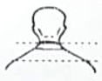 | 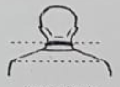 | 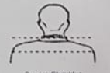
SLOPING | NORMAL | SQUARE
RANK
2ND LIEUTENANT ( ½“)
LIEUTENANT ( ½“)
( ¼“)
CAPTAIN ( ½”)
( ½“)
MAJOR ( ½”)
( ¼”)
( ½”)
LT COLONEL 3 X ½”

COLONEL
4 X ½“
NCM

HEIGHT
WEIGHT
AGE

BODY TYPE
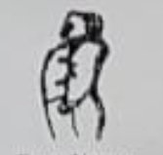 | 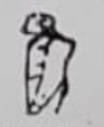 | 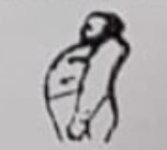
NARROW BACK / PROMINENT CHEST | NORMAL / FLAT CHEST ROUND BACK | FULL CHEST AND STOMACH / HOLLOW BACK

